

***Education 20/20 Inc.***

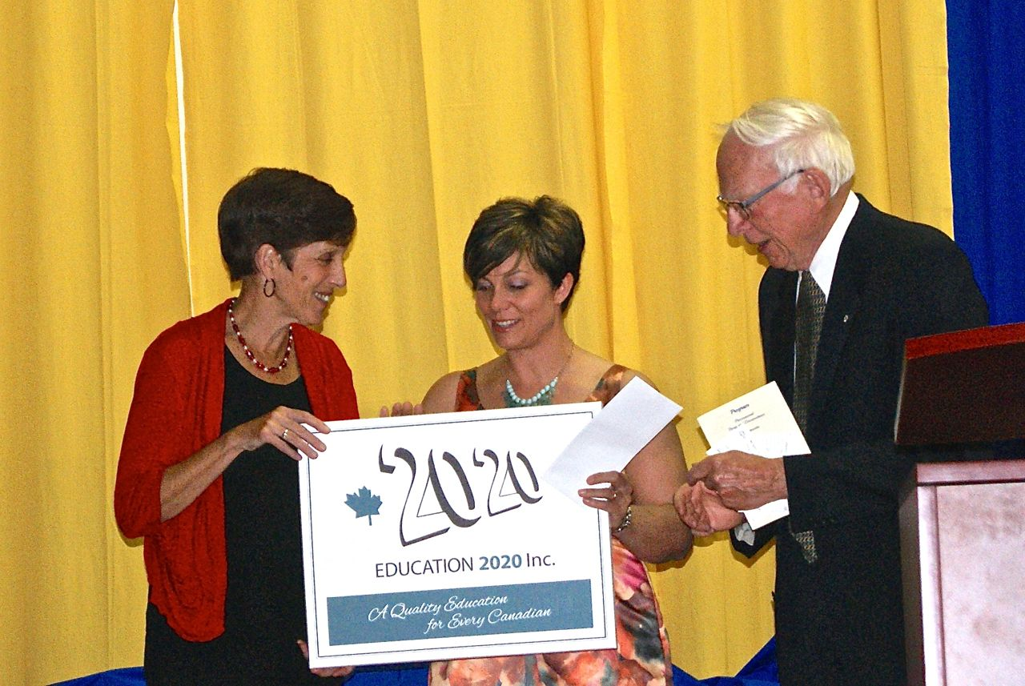

**2014 Excellence Award in education presented to**

**Kinkora Regional High School**

**A A quality education system is one where:**

* Learners are healthy
* Environments are safe and respectful
* Content is relevant
* Outcomes are linked to personal and community objectives
* Support is focused on learners and learning.
* Information and advice is timely and independent
* Teachers are professional, autonomous and accountable

***Education 20/20 Inc.***

101 Kent St., PO Box 624/rue Kent, BP 624

Charlottetown, PEI C1A 1M0 Canada

Tel: 902-892-2060

Email: [pei@education2020.ca](mailto:pei@education2020.ca)

[www.education2020.ca](http://www.education2020.ca)



***Education 20/20 Inc.***



**2014 Excellence Award in education presented to**

**Kinkora Regional High School**

**A quality education system is one where:**

* Learners are healthy
* Environments are safe and respectful
* Content is relevant
* Outcomes are linked to personal and community objectives
* Support is focused on learners and learning.
* Information and advice is timely and independent
* Teachers are professional, autonomous and accountable

***Education 20/20 Inc.***

101 Kent St., PO Box 624/rue Kent, BP 624

Charlottetown, PEI C1A 1M0 Canada

Tel: 902-892-2060

Email: [pei@education2020.ca](mailto:pei@education2020.ca)

[www.education2020.ca](http://www.education2020.ca)



***Education 20/20 Inc.***



**2014 Excellence Award in education presented to**

**Kinkora Regional High School**

**A quality education system is one where:**

* Learners are healthy
* Environments are safe and respectful
* Content is relevant
* Outcomes are linked to personal and community objectives
* Support is focused on learners and learning.
* Information and advice is timely and independent
* Teachers are professional, autonomous and accountable

***Education 20/20 Inc.***

101 Kent St., PO Box 624/rue Kent, BP 624

Charlottetown, PEI C1A 1M0 Canada

Tel: 902-892-2060

Email: [pei@education2020.ca](mailto:pei@education2020.ca)

[www.education2020.ca](http://www.education2020.ca)

***Education 20/20 Inc.***

**Education 20/20 Inc.** is an independent, broad based, national, not-for-profit education organization, located in Charlottetown, PEI and is governed by a volunteer Board of Directors.

**Vision: A** quality education for every Canadian.

**Mission:** To support and strengthen a culture of learning for all Canadians.

**Mandate:** To contribute to the education of our citizens by providing information, encouragement and support for a quality education for all citizens.

**Activities:**

* Awards
* Monthly electronic newsletter
* Website
* occasional papers
* Workshops

**Help change happen:**

* Volunteer
* Spread the word
* Ask questions
* Voice your opinion
* Donate today

***Education 20/20 Inc.***

**Education 20/20 Inc.** is an independent, broad based, national, not-for-profit education organization, located in Charlottetown, PEI and is governed by a volunteer Board of Directors.

**Vision: A** quality education for every Canadian.

**Mission:** To support and strengthen a culture of learning for all Canadians.

**Mandate:** To contribute to the education of our citizens by providing information, encouragement and support for a quality education for all citizens.

**Activities:**

* Awards
* Monthly electronic newsletter
* Website
* Occasional papers
* Workshops

**Help change happen:**

* Volunteer
* Spread the word
* Ask questions
* Voice your opinion
* Donate today

***Education 20/20 Inc.***

**Education 20/20 Inc.** is an independent, broad based, national, not-for-profit education organization, located in Charlottetown, PEI and is governed by a volunteer Board of Directors.

**Vision: A** quality education for every Canadian.

**Mission:** To support and strengthen a culture of learning for all Canadians.

**Mandate:** To contribute to the education of our citizens by providing information, encouragement and support for a quality education for all citizens.

**Activities:**

* Awards
* Monthly electronic newsletter
* Website
* Occasional papers
* Workshops

**Help change happen:**

* Volunteer
* Spread the word
* Ask questions
* Voice your opinion
* Donate today